UK Lo

Backford Parish Council

ANNUAL GENERAL MEETING

Tuesday 11th May 2021
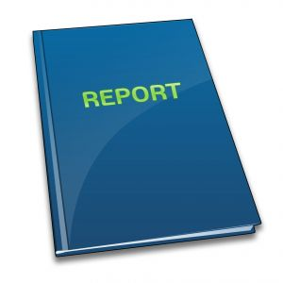

CHAIRMAN'S REPORT
2020-21

Whilst enjoying my many years in office as Chairmen for Backford Parish Council, I can honestly say this has been the most challenging of years for all of us. The ever changing responsibilities of the Council certainly keep the position both challenging and rewarding.

COVID changed things for all of us and made us consider new ways of undertaking council business with the inevitability of working on line and slowing responses to issues down. I am pleased to report how well the councillors adapted to ensure our business continuity. Well done all.

My thanks must certainly go to all of the Parish Councillors for all of their help in supporting me in his role.

I would also like to thank our team of Council staff who have assisted us over the past year and not least Borough Councillor Simon Eardley without whom we would have struggled to achieve our goals on behalf of parishioners, he has been a tremendous support to us all.

My special thanks go to Debbie Jones, Clerk to the Council for all her hard work and all the work she tells me to do!

The local Election this year has been uncontested. This means all of my fellow Councillors will be back in post and continuing the excellent work they do on behalf of the Council.

During the past year the Council has worked hard on behalf of its parishioners and items of note are: -
- Facilitating council meetings on Zoom
- Facilitating overview of planning applications
- Contributing substantially to the development of the village hall project on your behalf to secure a great new facility
- Monitoring local speeding issues and working with the Police and local Borough Councillor to develop and to improve the difficulties on our roads
- Working with Mollington Parish and Lea by Backord Parish on the development on the local newsletter supported by Borough Councillor Simon Eardley
- Introduction of new websites and this was undertaken as a collective with Backford and Mollington Councils in order to ensure value for money.
- Ensuring communication with CWAC to highlight damage to our countryside areas
- Considering and implementing new projects such as the new noticeboard in Church Lane
- Working to improving the drainage issues within the Backford area
As always, the Council strives to improve itself and its facilities on behalf of parishioners.

As you can see, Backford Parish Council has achieved a great deal this year and the Council will continue to plan local improvements for the future.

Of course, none of this would be possible without the dedication and commitment of a fantastic team. As such, I would like to thank the all Members of the Council for the work they have carried out on behalf of parishioners during the past year.

It has been an honour and a privilege to have served as Chairman to Backford Parish Council during the past year. I believe that our actions have had a continued positive impact on providing constantly improving facilities within the Parish and will continue to do so in future years.

Best Regards,

Cllr Mike Cheers
Chairman of Backford Parish Council
8th May 2021

